Evaluation of special math functions in Calcpad
.
This workheet defines some of the most common special functions in ℝ, by using the existing numerical methods in Calcpad only in stable and precise way (as possible)
Gamma and related functions
Euler-Mascheroni constant - $γ=0.5772$
Gamma function - $Γ\left(x\right)=\frac{1}{x}·\int_{0}^{1}{{\left(\text{-}\text{ln}\left(t\right)\right)}^{x} dt}$
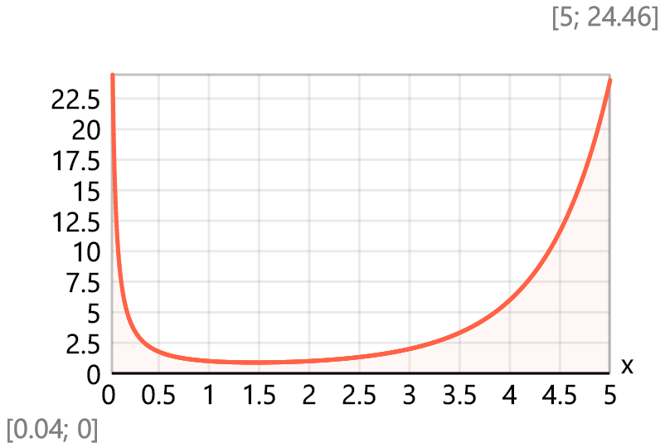
Checks: $Γ\left(0\right)=+∞$ , $Γ\left(4\right)=6$ = 3!, $Γ\left(5\right)=24$ = 4!
$x=50$ , $x!=3.041\text{×}{10}^{64}$ , $\frac{Γ\left(x+1\right)-x!}{x!}=\text{-}3.844\text{×}{10}^{\text{-}16}$
Digamma function - $ψ\left(x\right)=\int_{0}^{1}{\frac{1-t^{x-1}}{1-t} dt}-γ$
Polygamma function - $ψ_{m}\left(m;x\right)={\left(\text{-}1\right)}^{m+1}·\int_{ε}^{1}{\frac{{\left(\text{-}\text{ln}\left(t\right)\right)}^{m}·t^{x-1}}{1-t} dt}$, where $ε={10}^{\text{-}300}$
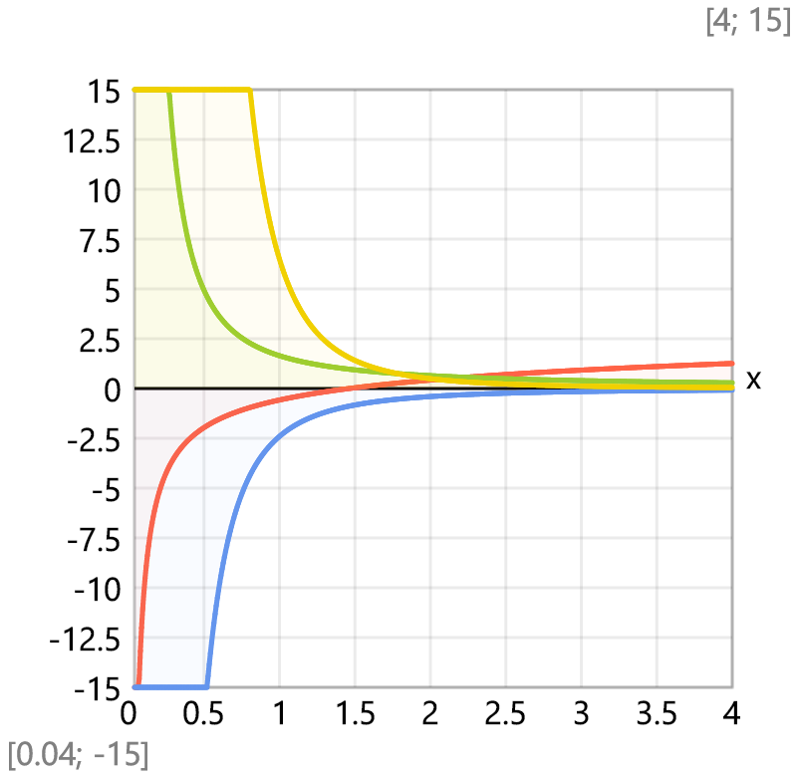
Checks:
$$ψ_{m}\left(1;1\right)-\frac{π^{2}}{6}=2.22\text{×}{10}^{\text{-}16} ψ_{m}\left(3;1\right)-\frac{π^{4}}{15}=2.665\text{×}{10}^{\text{-}15}$$
$ψ_{2,1}=\text{-}2.404$ -2 times Apéry constant, $ψ_{m}\left(2;1\right)-ψ_{2,1}=\text{-}8.438\text{×}{10}^{\text{-}15}$
Incomplete Gamma functions:
$γ\left(s;x\right)=\int_{e^{\text{-}x}}^{1}{{\left(\text{-}\text{ln}\left(t\right)\right)}^{s-1} dt}$ or $γ\left(s;x\right)=\frac{1}{s}·\left(\int_{e^{\text{-}x}}^{1}{{\left(\text{-}\text{ln}\left(t\right)\right)}^{s} dt}+x^{s}·e^{\text{-}x}\right)$
$Γ_\left(s;x\right)=\int_{0}^{e^{\text{-}x}}{{\left(\text{-}\text{ln}\left(t\right)\right)}^{s-1} dt}$ or $Γ_\left(s;x\right)=\frac{1}{s}·\left(\int_{0}^{e^{\text{-}x}}{{\left(\text{-}\text{ln}\left(t\right)\right)}^{s} dt}-x^{s}·e^{\text{-}x}\right)$
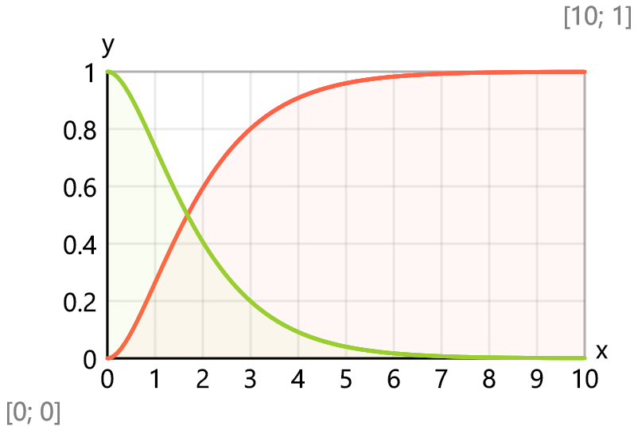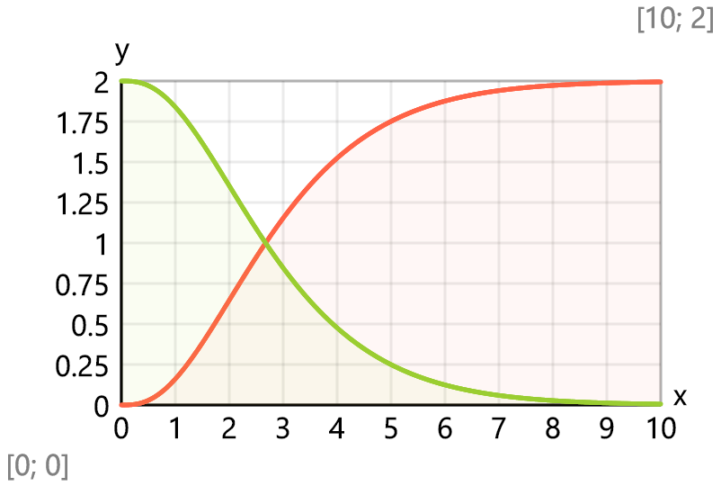
Beta function - $B\left(x;y\right)=\frac{Γ\left(x\right)·Γ\left(y\right)}{Γ\left(x+y\right)}$
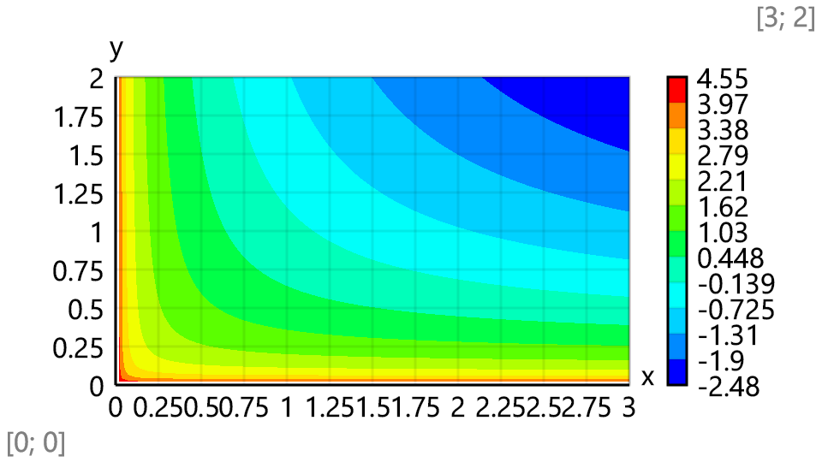
Checks: $B\left(3;2\right)·12=1$ , $B\left(4;3\right)·60=1$
Incomplete Beta function - $B\left(x;a;b\right)=\int_{ε}^{x}{t^{a-1}·{\left(1-t\right)}^{b-1} dt}$
$$Precision={10}^{\text{-}6}$$
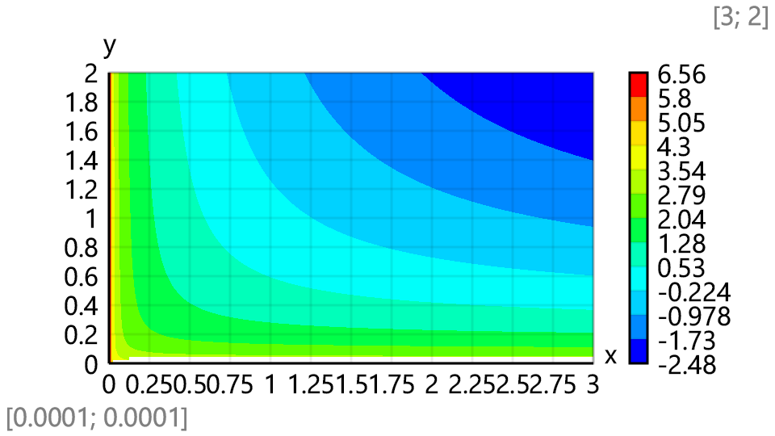
Checks: $B\left(1;1;1\right)=1$ , $B\left(1;2;3\right)·12=1$ , $\frac{\text{-}B\left(2;2;2\right)·3}{2}=1$
Riemann Zeta function - $ζ\left(x\right)=\frac{1}{Γ\left(x\right)}·\int_{0}^{1}{\frac{{\left(\text{-}\text{ln}\left(t\right)\right)}^{x-1}}{1-t} dt}$
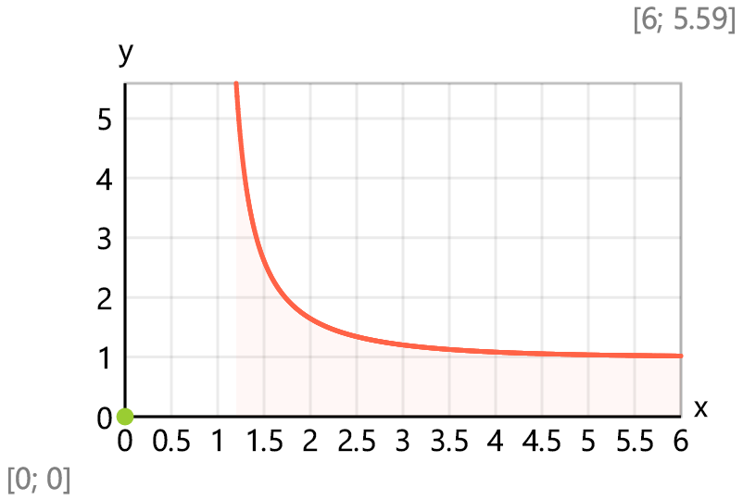
Checks: $Precision={10}^{\text{-}15}$
$$ζ\left(2\right)-\frac{π^{2}}{6}=\text{-}1.332\text{×}{10}^{\text{-}15} ζ\left(4\right)-\frac{π^{4}}{90}=0$$
$ζ_{3}=1.202$ - Apéry constant $ζ\left(3\right)-ζ_{3}=3.997\text{×}{10}^{\text{-}15}$
$$Precision={10}^{\text{-}4}=0.0001$$
Dirichlet Eta function - $η\left(x\right)=\frac{1}{Γ\left(x\right)}·\int_{0}^{1}{\frac{{\left(\text{-}\text{ln}\left(t\right)\right)}^{x-1}}{1+t} dt}$
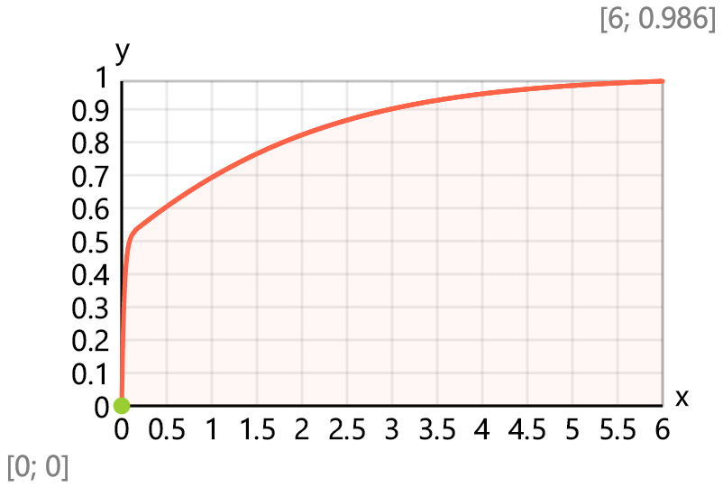
Checks:
$η_{0.5}=0.6049$ $η\left(0.5\right)-η_{0.5}=4.637\text{×}{10}^{\text{-}8}$
$Precision={10}^{\text{-}15}$ $η\left(1\right)-\text{ln}\left(2\right)=7.772\text{×}{10}^{\text{-}16}$
$η\left(2\right)-\frac{π^{2}}{12}=\text{-}2.22\text{×}{10}^{\text{-}16}$ $η\left(4\right)-\frac{7·π^{4}}{720}=\text{-}1.11\text{×}{10}^{\text{-}16}$
Error function - $erf\left(x\right)=\frac{2·\text{sign}\left(x\right)}{\sqrt{π}}·\int_{0}^{\left|x\right|}{e^{\text{-}\left(t^{2}\right)} dt}$ , $erfc\left(x\right)=1-erf\left(x\right)$
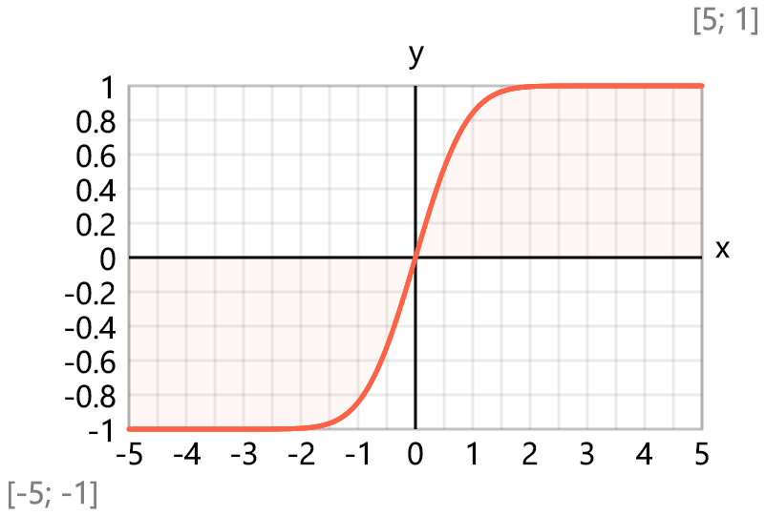
Integral functions
Fresnel integrals: $C\left(x\right)=\int_{0}^{x}{\text{cos}\left(t^{2}\right) dt}$, $S\left(x\right)=\int_{0}^{x}{\text{sin}\left(t^{2}\right) dt}$
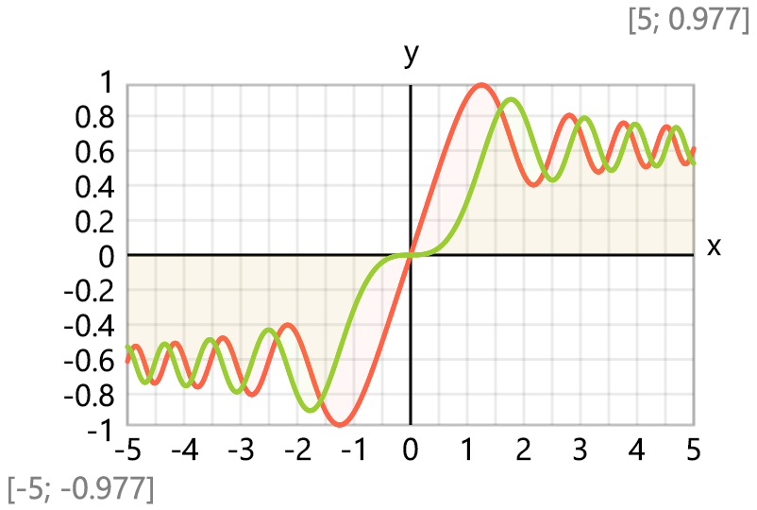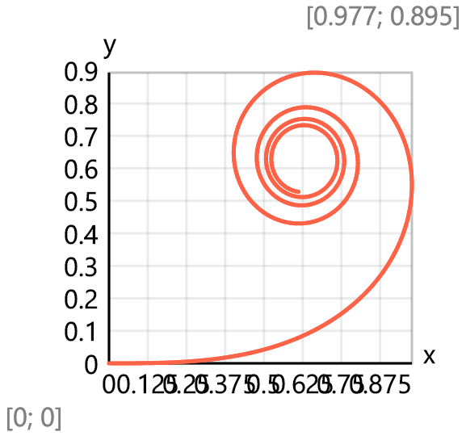
Sine and cosine integrals:
$Ci\left(x\right)=\{\begin{matrix}\text{ if }x≡0: & \text{-}1/0 \\ \text{ else:} & γ+\text{ln}\left(x\right)+\int_{0}^{x}{\frac{\text{cos}\left(t\right)-1}{t} dt}\end{matrix}$ , $Si\left(x\right)=\{\begin{matrix}\text{ if }x≡0: & 0 \\ \text{ else:} & \int_{0}^{x}{\frac{\text{sin}\left(t\right)}{t} dt}\end{matrix}$
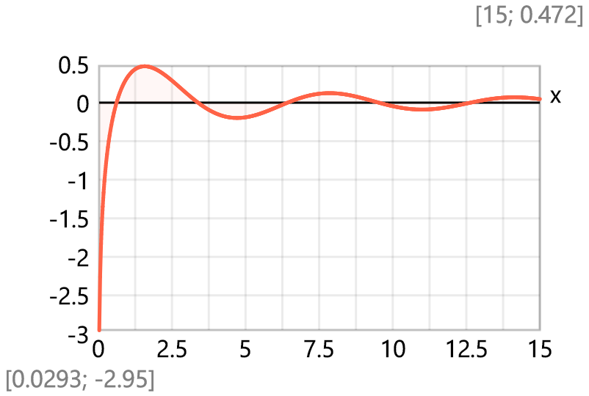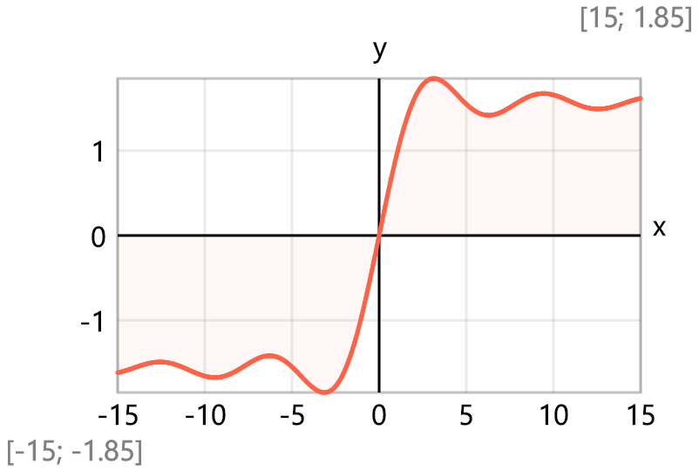
Hyperbolic sine and cosine integrals:
$Chi\left(x\right)=\{\begin{matrix}\text{ if }x≡0: & \text{-}1/0 \\ \text{ else:} & γ+\text{ln}\left(x\right)+\int_{0}^{x}{\frac{\text{cosh}\left(t\right)-1}{t} dt}\end{matrix}$ , $Shi\left(x\right)=\{\begin{matrix}\text{ if }x≡0: & 0 \\ \text{ else:} & \int_{0}^{x}{\frac{\text{sinh}\left(t\right)}{t} dt}\end{matrix}$
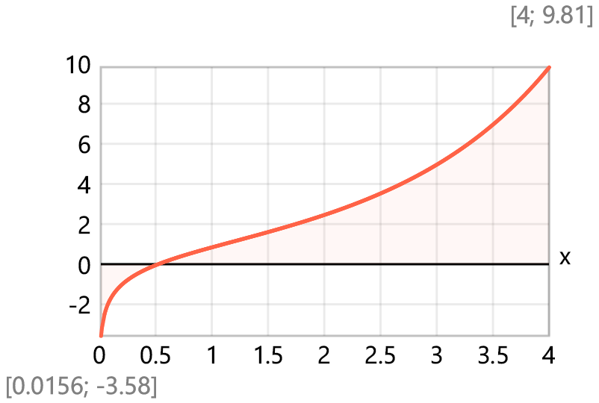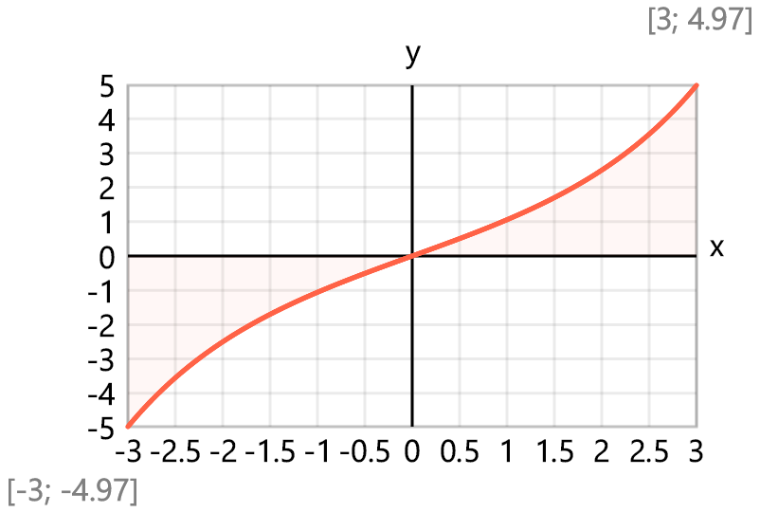
$${li}_{2}=1.045$$
Logarithmic Integral - $Li\left(x\right)=\int_{2}^{x}{\frac{1}{\text{ln}\left(t\right)} dt}$, $li\left(x\right)=\{\begin{matrix}\text{ if }x<1: & \int_{0}^{x}{\frac{1}{\text{ln}\left(t\right)} dt} \\ \text{ else:} & Li\left(x\right)+{li}_{2}\end{matrix}$
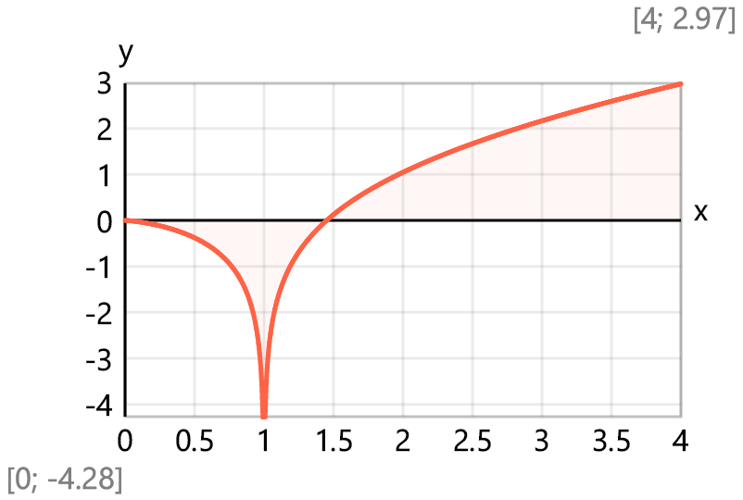
Exponential Integral - $E_{1}\left(x\right)=\text{-}\int_{0}^{e^{\text{-}x}}{\frac{1}{\text{ln}\left(t\right)} dt}$, $Ei\left(x\right)=\{\begin{matrix}\text{ if }x<0: & \text{-}E_{1}\left(\text{-}x\right) \\ \text{ if }x>0: & {li}_{2}+Li\left(e^{x}\right)\end{matrix}$
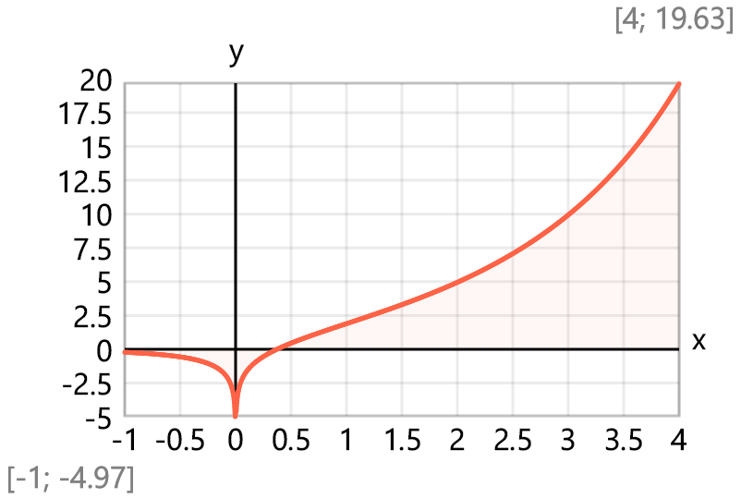
Dawson′s Integral - $F_{D}\left(x\right)=e^{\text{-}\left(x^{2}\right)}·\int_{0}^{x}{e^{t^{2}} dt}$
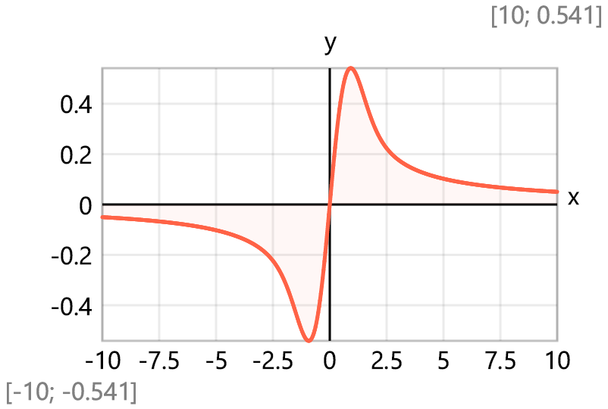
Elliptic integrals
Incomplete elliptic integral of the first kind - $F\left(φ;m\right)=\int_{0}^{φ}{\frac{1}{\sqrt{\text{max}\left(1-m·{\text{sin}\left(t\right)}^{2};ε\right)}} dt}$
Complete elliptic integral of the first kind - $K\left(m\right)=F\left(\frac{π}{2};m\right)$
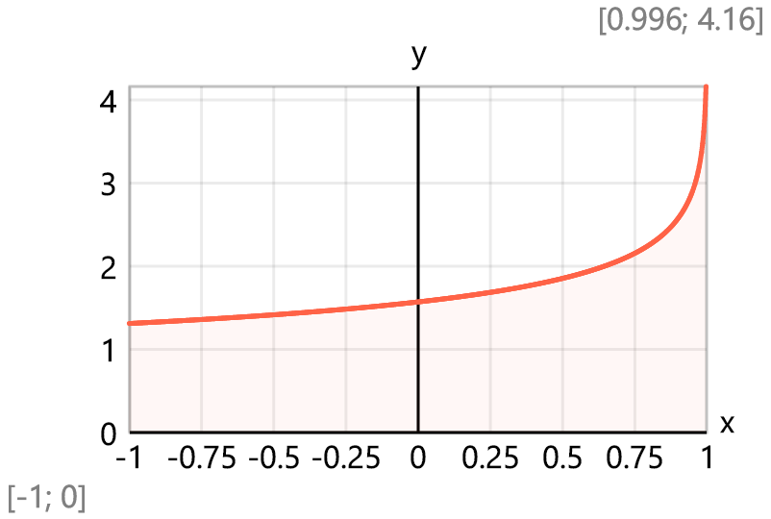
Incomplete elliptic integral of the second kind - $E_\left(φ;m\right)=\int_{0}^{φ}{\sqrt{1-m·{\text{sin}\left(t\right)}^{2}} dt}$
Complete elliptic integral of the second kind - $E\left(m\right)=E_\left(\frac{π}{2};m\right)$
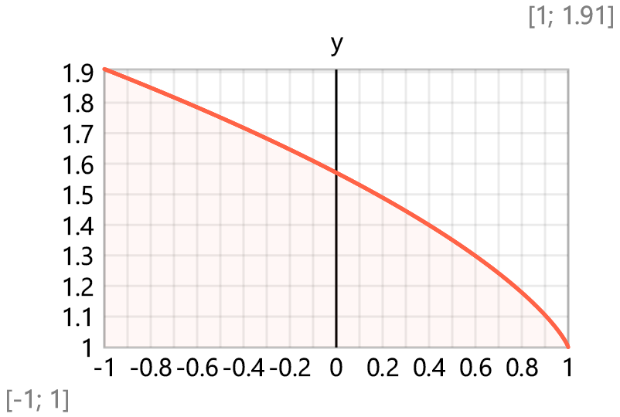
Incomplete elliptic integral of the third kind -
$$Π_\left(n;φ;m\right)=\int_{0}^{φ}{\frac{1}{\text{max}\left(1-n·{\text{sin}\left(t\right)}^{2};ε\right)·\sqrt{\text{max}\left(1-m·{\text{sin}\left(t\right)}^{2};ε\right)}} dt}$$
Complete elliptic integral of the third kind - $Π\left(n;m\right)=Π_\left(n;\frac{π}{2};m\right)$, $Π\left(0.4;0.6\right)=2.591$
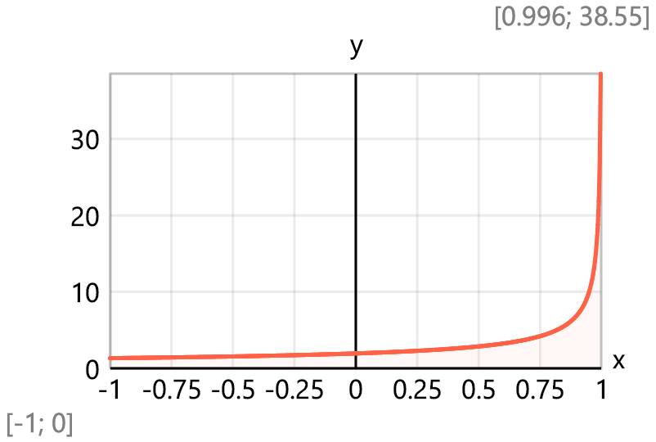
Jacobi elliptic functions
Jacobi elliptic amplitude
Gudermannian function - $gd\left(x\right)=\text{asin}\left(\text{tanh}\left(x\right)\right)$ = am(u; 1)
Approximate value for small u, m, m′
$$am_\left(u;m\right)=gd\left(u\right)+\frac{1-m}{4}·\left(\text{sinh}\left(u\right)·\text{cosh}\left(u\right)-u\right)·\text{sech}\left(u\right)$$
To avoid numerical instabilities, the function for larger values of u is reduced to the interval [0; K(m)] where the elliptic integral is evaluated within [0; π/2]. This is performed by using the following quasi-periodical relationships:
am(u + 2K(m), m) = am(u, m) + π, for u ≥ 2K(m)
am(u, m) = π - am(2K(m) - u, m), for u < 2K(m)
Function for evaluation of Jacobi elliptic amplitude:
$$am\left(u;m\right)=$$
$$\{\begin{matrix}\text{ if }m≡0: & u \\ \text{ if }m≡1: & \text{asin}\left(\text{tanh}\left(u\right)\right) \\ \text{else:} & |\begin{matrix}{ K}_{m2}=K\left(m\right)·2; s=\text{sign}\left(u\right); u=\left|u\right| \\ n=\text{floor}\left(\frac{u}{K_{m2}}\right); u=u-n·K_{m2}; y=\frac{u·π}{K_{m2}} \\ am=\{\begin{matrix}\text{ if }u>\frac{K_{m2}}{2}: & π-\text{\$Root}\left\{F\left(φ;m\right)=K_{m2}-u;φ∈\left[0;\frac{π}{2}\right]\right\} \\ \text{ else:} & \text{\$Root}\left\{\begin{aligned}F\left(φ;m\right)=u; \\ φ∈\left[\text{max} \left(0;y-1\right);\text{min}\left(\frac{π}{2};y+1\right)\right]\end{aligned}\right\}\end{matrix} \\ s·\left(am+n·π\right)\end{matrix} \end{matrix}$$
Plot for $m=1$ , $1-m={10}^{\text{-}6}$, $Precision=\frac{{10}^{\text{-}15}}{{\sqrt[3]{1-m}}^{2}}={10}^{\text{-}11}$
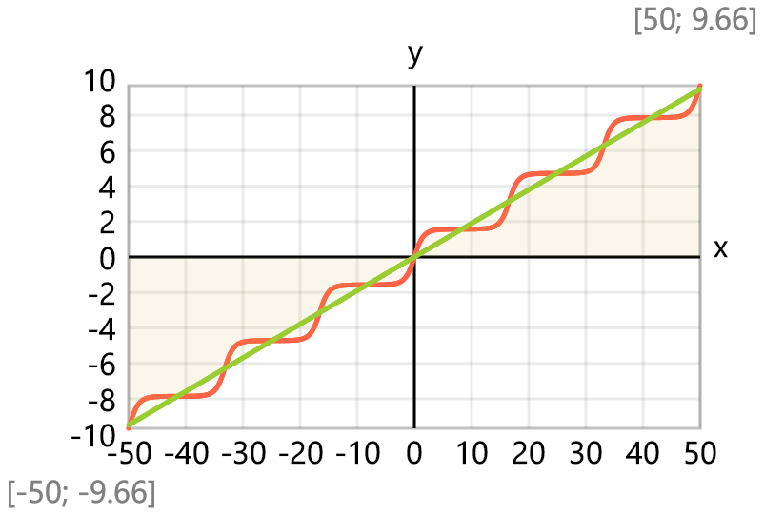

Check: am(x; 0) = x Check: am(x; 1) = gd(x)
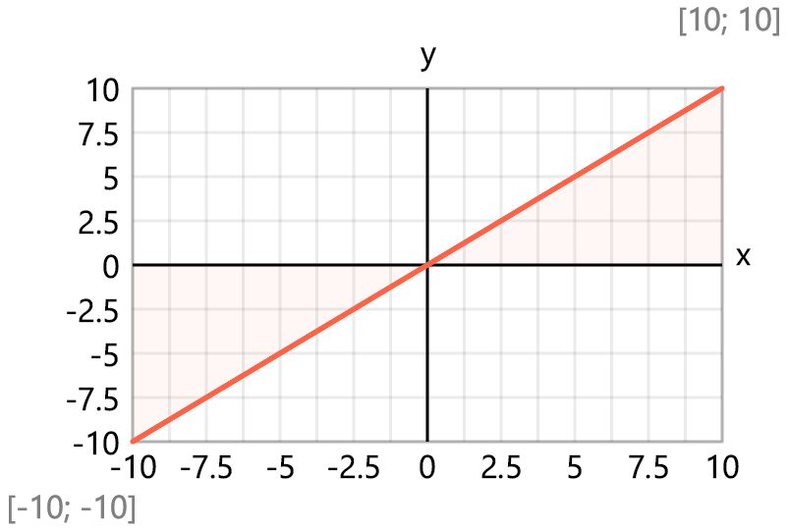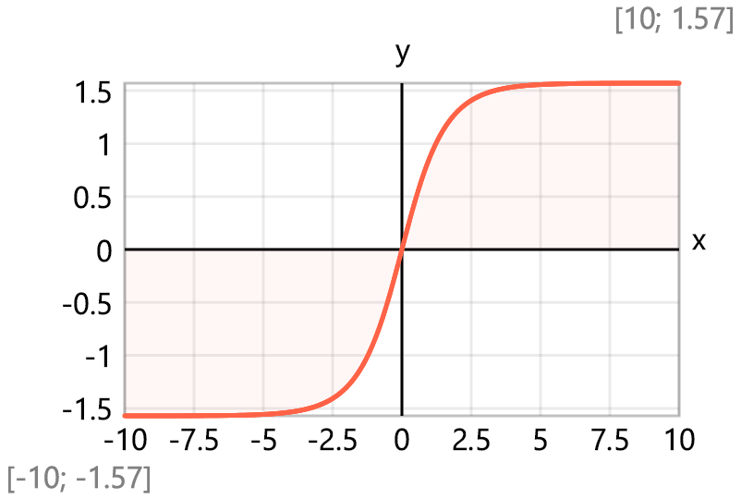
Jacobi elliptic functions
$sn\left(u;m\right)=\text{sin}\left(am\left(u;m\right)\right)$ $cn\left(u;m\right)=\text{cos}\left(am\left(u;m\right)\right)$
$dn\left(u;m\right)=|\begin{matrix}sn=\text{sin}\left(am\left(u;m\right)\right) \\ \sqrt{1-m·sn·sn}\end{matrix}$ $cs\left(u;m\right)=|\begin{matrix}φ=am\left(u;m\right) \\ \frac{\text{cos}\left(φ\right)}{\text{sin}\left(φ\right)}\end{matrix}$
$cd\left(u;m\right)=|\begin{matrix}φ=am\left(u;m\right) \\ sn=\text{sin}\left(φ\right) \\ cn=\text{cos}\left(φ\right) \\ dn=\sqrt{1-m·sn·sn} \\ cn/dn\end{matrix}$ $dc\left(u;m\right)=|\begin{matrix}φ=am\left(u;m\right) \\ sn=\text{sin}\left(φ\right) \\ cn=\text{cos}\left(φ\right) \\ dn=\sqrt{1-m·sn·sn} \\ dn/cn\end{matrix}$
$sc\left(u;m\right)=|\begin{matrix}φ=am\left(u;m\right) \\ \frac{\text{sin}\left(φ\right)}{\text{cos}\left(φ\right)}\end{matrix}$ $sd\left(u;m\right)=|\begin{matrix}φ=am\left(u;m\right) \\ sn=\text{sin}\left(φ\right) \\ dn=\sqrt{1-m·sn·sn} \\ sn/dn\end{matrix}$
$$ds\left(u;m\right)=|\begin{matrix}φ=am\left(u;m\right) \\ sn=\text{sin}\left(φ\right) \\ dn=\sqrt{1-m·sn·sn} \\ dn/sn\end{matrix}$$
Checks: $Precision={10}^{\text{-}15}$
$am\left(1;0.5\right)=0.9323$ , $dn\left(1;0.5\right)=0.8232$
$s=sn\left(1;0.5\right)=0.803$ , $c=cn\left(1;0.5\right)=0.596$
$$c^{2}+s^{2}=1$$

Reciprocal Jacobi elliptic functions
$ns\left(u;m\right)=\frac{1}{sn\left(u;m\right)}$ , $nc\left(u;m\right)=\frac{1}{cn\left(u;m\right)}$ , $nd\left(u;m\right)=\frac{1}{dn\left(u;m\right)}$
Bessel functions
Bessel functions of the first kind - $J\left(n;x\right)=\frac{1}{π}·\int_{0}^{π}{\text{cos}\left(n·θ-x·\text{sin}\left(θ\right)\right) dθ}$
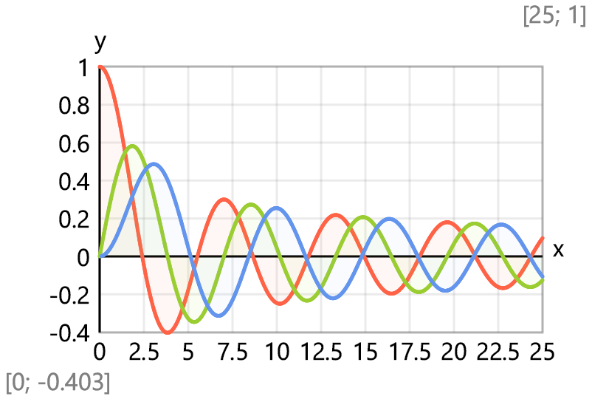
Asymptotic expansion (use for x > 150) - $J_{a}\left(n;x\right)=\sqrt{\frac{2}{π·x}}·\left(\text{cos}\left(x-\frac{n·π}{2}-\frac{π}{4}\right)\right)$
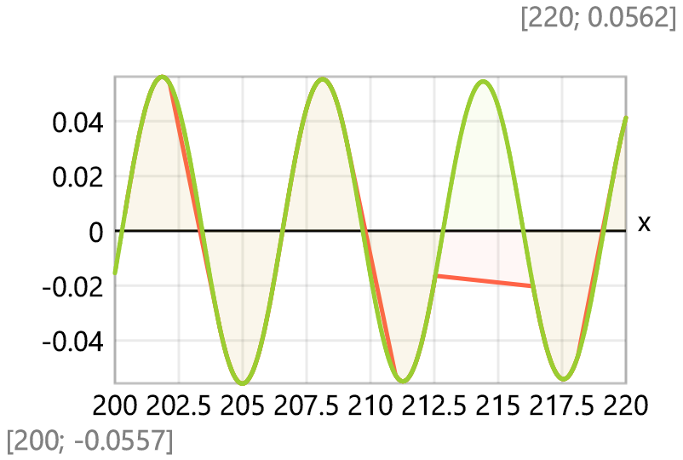
Dynamic limit for numerical stability – $inf\left(x\right)=$ $\frac{20}{1+\text{ln}\left(\text{max}\left(x;e\right)\right)}$
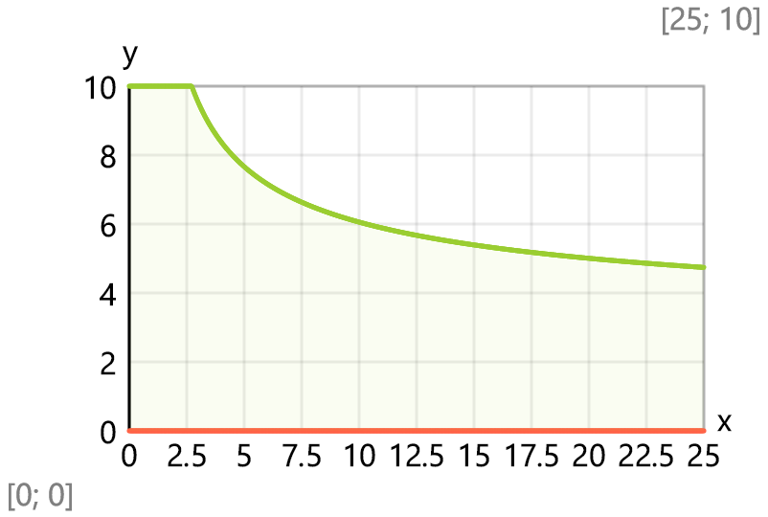
Bessel functions of the second kind -$Y\left(n;x\right)=\frac{1}{π}·\int_{0}^{π}{\text{sin}\left(x·\text{sin}\left(θ\right)-n·θ\right) dθ}-\frac{1}{π}·\int_{0}^{inf\left(x\right)}{\left(\text{exp}\left(n·t\right)+{\left(\text{-}1\right)}^{n}·\left(\text{exp}\left(\text{-}n·t\right)\right)\right)·\left(\text{exp}\left(\text{-}x·\text{sinh}\left(t\right)\right)\right) dt}$
Asymptotic expansion (use for x > 150) - $Y_{a}\left(n;x\right)=\sqrt{\frac{2}{π·x}}·\left(\text{sin}\left(x-\frac{n·π}{2}-\frac{π}{4}\right)\right)$
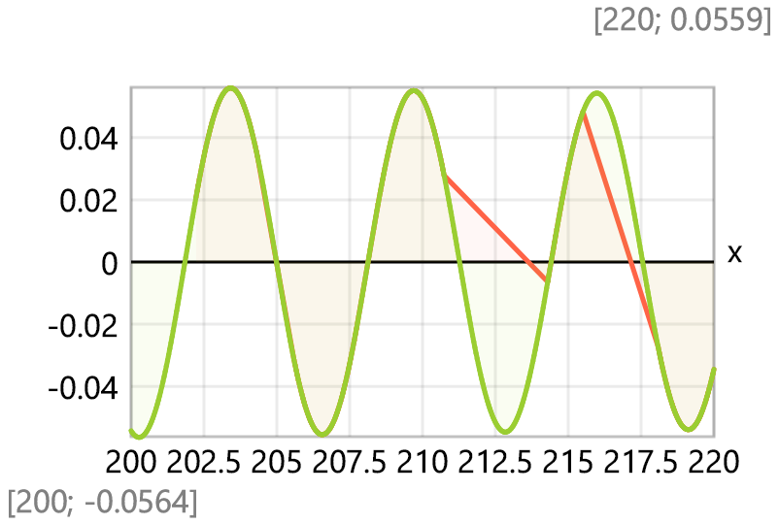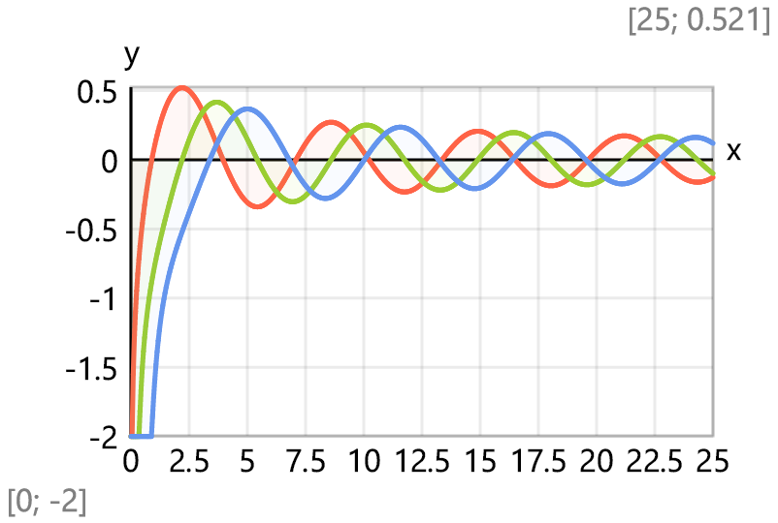
Recurrence test: $n=1$ , $x=100$
$$Y\left(n-1;x\right)+Y\left(n+1;x\right)-\frac{2·n}{x}·Y\left(n;x\right)=\text{-}1.11\text{×}{10}^{\text{-}16}$$
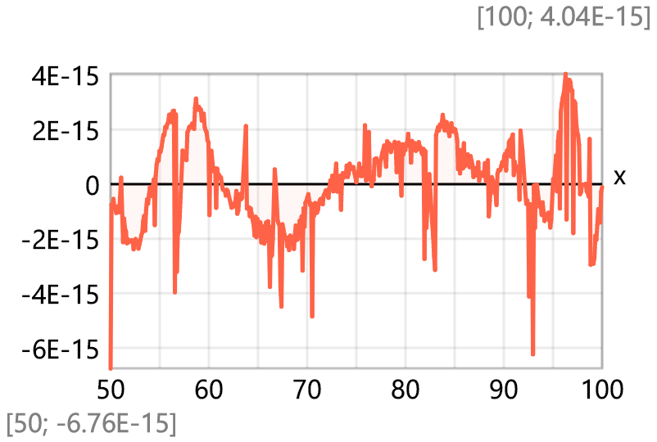
Wronskian test: W(x) = J₁(x) · Y₀(x) - J₁(x) · Y₀(x) = 2/(π · x)
$Wr\left(x\right)=J\left(1;x\right)·Y\left(0;x\right)-J\left(0;x\right)·Y\left(1;x\right)$, $Wr\left(x\right)-\frac{2}{π·x}=2.177\text{×}{10}^{\text{-}16}$
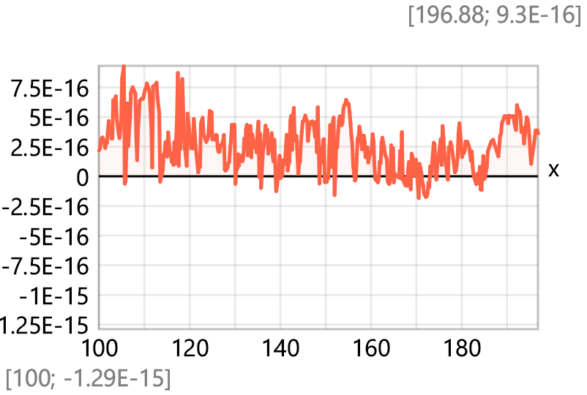
Modified Bessel functions of the first kind
Modified Bessel functions of the second kind
Airy functions

Lambert W function
Helper function - $\ln_{2}\left(x\right)=\text{ln}\left(\text{ln}\left(x\right)\right)$
Approximate value - $W_{a}\left(x\right)=\text{ln}\left(x\right)-\ln_{2}\left(x\right)$
Secondary value - $W_{b}\left(x\right)=\frac{\ln_{2}\left(x\right)}{\text{ln}\left(x\right)}$
Lower bound - $W_{btm}\left(x\right)=W_{a}\left(x\right)+0.5·W_{b}\left(x\right)$
Upper bound - $W_{top}\left(x\right)=W_{a}\left(x\right)+\frac{e}{e-1}·W_{b}\left(x\right)$
The function - $W\left(x\right)=\{\begin{matrix}\text{ if }x<e: & \text{\$Root}\left\{ξ·\text{exp}\left(ξ\right)=x;ξ∈\left[\text{-}1;1\right]\right\} \\ \text{ else:} & \text{\$Root}\left\{ξ·\text{exp}\left(ξ\right)=x;ξ∈\left[W_{btm}\left(x\right);W_{top}\left(x\right)\right]\right\}\end{matrix}$
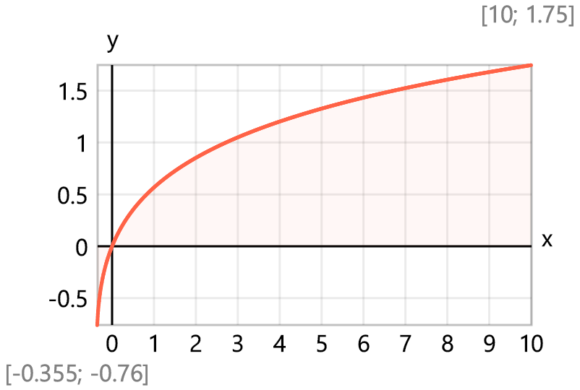
Omega constant - $Ω=0.5671$
Check: $W\left(1\right)-Ω=0$ , $W\left(e\right)-1=0$
Relative error plot
